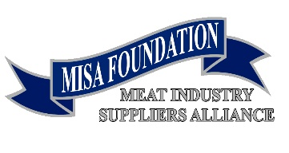

Media Contact:
David Seckman
FPSA CEO/President
703.663.1200
dseckman@fpsa.org

FOR IMMEDIATE RELEASE July 29, 2019

The Meat Industry Suppliers Alliance Foundation

Announces Scholarship Recipients

McLean, VA - The Meat Industry Suppliers Alliance Foundation today announced it has awarded seven $10,000 scholarships that will be used towards completing the winners’ respective degrees within the meat sciences discipline. The scholarship winners are:

Taylor Price, Oklahoma State University Jennifer Vuia-Riser, University of Tennessee
Cole Perkins, Texas Tech University Hannah Williams, Kansas State University
Thomas Fletcher, Texas Tech University Luke Fuerniss, Colorado State University
Brianna Britton, Purdue University

“The MISA Foundation is proud to announce the list of outstanding scholarships winners for the 2019-2020 school year” stated Bob Grote, Chairman of the MISA Foundation and CEO of Grote Company. “The success of the FPSA Auction this year, due in large part to the contributions of MISA members, has allowed us to continue in the spirit of giving, enabling us to award these extraordinary students and their accomplishments. The Foundation Board congratulates all the winners and wishes them the best in the upcoming school year and all future endeavors. Finally, I would like to thank our members and participants of the FPSA Auction for their overwhelming support with their donations and purchase of auction items where we raised over $155,000.”

David Seckman, President and CEO of the Food Processing Suppliers Association stated: “These MISA Scholarships are an integral part of our Association’s “Giving Back” program. “These scholarships highlight MISA’s commitment to creating future leaders in the meat industry. Working with these students and universities is important to us because we know that the industry will benefit from these amazing graduates when they enter the work force.”

###

The MISA Foundation is a non-profit tax-exempt organization formed to nurture, promote and develop state-of-the-art technology and technical information by furthering the education of meat and food science students.

